### DESIGN PROJECT REPORTS OF ...

### TITLE

**(TIMES NEW ROMAN, 12, BOLD)**

Team Name (Times New Roman, 12)

First Author (Times New Roman, 12) Second Author (Times New Roman, 12) Third Author (Times New Roman, 12)

...continue to list all authors / team members

Date (Times New Roman, 12)

*Abstract* (Times New Roman, 12, justified, placed on title page)

The report should start with an abstract of approximately 100 words, summarizing the objective, contents, results, and conclusions of the report as specifically as possible.

The heading of the Abstract should be italic. Update the abstract as more sections of the report are competed.

[Note: The **purpose** of the design report is to describe and justify the final design. The **audience** is primarily decision makers (technical and business project managers) in your company and internal technical staff. The **style** (based on guidelines in Style Guide [Shipley and Associates, 1987] and Write to the Top [DiGregorio, 1995] should follow these guidelines:

1. Take the active voice (use first person nouns and direct, forceful verbs);
2. Use pronouns when recommending something, drawing conclusions, or conveying decisions;
3. Write the way you talk - make it easy for the reader to get your point;
4. Keep most sentences and paragraphs short.

**Formatting Guidelines:** The entire body text of the report should be Times New Roman, 12, with 1 inch margins. Major headings should be numbered consecutively, 1.0, 2.0, 3.0, etc, typed in bold face with a font size of 16. Sub-headings should be numbered consecutively, 1.1, 1.2, etc, typed in bold face with a font size of 14. Finally, sub-sub-headings should also be numbered consecutively, 1.1.1, 1.1.2, etc., typed in bold face with a size 12 font face. It is not recommended to go beyond three levels of headings.

# Introduction (Times New Roman 16, Bold, left)

Use the introduction section to provide some background information on the overall design problem domain. This introductory information should come from your literature search – Library, Internet, trade magazines, etc. Key points to cover:

* Set the **context**: Help the reader understand general information about the problem or need area, including any necessary definitions, statistics, etc. Use pictures and visual images as much as possible.
* Explain the **purpose**: why is this work important?
* Set the **scope**: How far can you or will you go to solve the problem?
* State the **objectives**: In short statements or a bullet list, identify the specific objectives of your work - things that can be assessed at the end of the project to determine if you were successful.

### Important Note: All sources that are not your own ideas must be referenced.

For your reports, please use the *parenthetical references: author-date system*. A sample reference list addressing each of the five main types of information sources is given at end. These include: websites (Swanson, 1999), journals (Muriru and Daewoo, 2002), books (Zacharia and Daudi, 2001), conference proceedings (Peters et al., 2001) and patents (Wen-Cheng, 1994). For more information on ethical standards for publications (for the example of ASME journals), see

[http://journaltool.asme.org/Help/AuthorHelp/WebHelp/JournalsHelp.htm#Guidelines/Ethical_Standards.htm.](http://journaltool.asme.org/Help/AuthorHelp/WebHelp/JournalsHelp.htm%23Guidelines/Ethical_Standards.htm)

* 1. **Initial Needs Statement (Times New Roman, 14, left)**

Provide a brief paragraph describing the initial needs statement – the needs statement itself is usually given to the design team. Please also include some initial discussion of the need statement, linked to the introductory material.

# Customer Needs Assessment

This section describes the iterative FOCUS process for defining the customer (360 degree perspective), developing appropriate interview and observation guides, collecting data, and converting it to customer requirements statements (customer needs). Please show/describe the iterative nature of the process to illustrate how the project was impacted by customer input. This section should include descriptive text and several tables and figures, including:

* + 1. An initial customer needs list obtained from interviews and observations (refer to Table 1). Note that all table captions are placed on *top* of the tables. Please note that all tables are numbered consecutively. **Please make sure that a table is not split between two pages.** Move the table to a location where it can fit. If the table is too big to fit, split the table into two separate tables.
    2. A table listing the hierarchal design objective list, that has been augmented with constraints and functions (refer to Table 2). Note that the constraints and functions are formatted differently for easy identification.
    3. Include the most relevant copy of your interview guide and observation guide in the Appendix, and reference it from this section.

### Table 1. Initial Customer Needs List Obtained from Interviews and Observations (Times New Roman, 12, Bold, Centered)

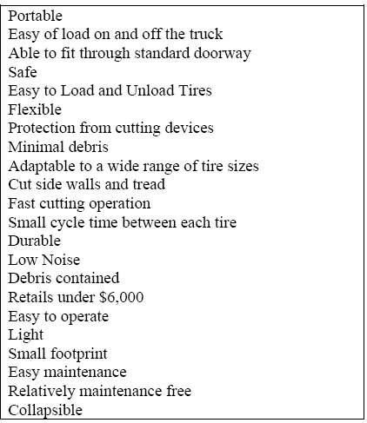

**Table 2. Hierarchal Customer Needs List (With Weighting factors) (Times New Roman, 12, Bold, Centered)**

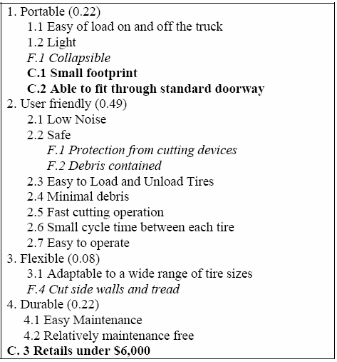

* 1. **Weighting of Customer Needs**

This section should begin with a brief introduction on the importance of weighting, and then provide a description and/or tables that show how the weights were calculated. The resources for making decisions discussed in class would be a good tool to use here. Figure 1 illustrates the use of one method, the Analytical Hierarchy Process (AHP), to create a weighted hierarchal customer needs list. It is very important to include figures and tables to show how the decisions were made, not just what the decisions are.

Like tables, all figures are numbered consecutively. Unlike tables, however, figure captions are typically placed at the bottom of the figure. This section should build on and make reference to the weighted hierarchal customer needs list.

|  |  |  |  |  |  |  |
| --- | --- | --- | --- | --- | --- | --- |
|  | Portable | User Fr. | Flexible | Durable | Total | Weighting |
| Portable | 1.00 | 0.33 | 3.00 | 1.00 | 5.33 | 0.22 |
| User Fl. | 3.00 | 1.00 | 5.00 | 3.00 | 12.00 | 0.49 |
| Flexible | 0.33 | 0.20 | 1.00 | 0.33 | 1.87 | 0.08 |
| Durable | 1.00 | 0.33 | 3.00 | 1.00 | 5.33 | 0.22 |

### Figure 1. Example of AHP Pair wise Comparison Chart to Determine Weighting for Main Objective Categories

**3.0 Revised Needs Statement and Target Specifications**

Using the initial problem statement and the knowledge gathered from the customer needs, describe a revised needs statement that provides a more concise description of the design problem.

Clearly define the target specifications and the design criteria that define the problem (generated from the customer requirements and engineering standards). Include the initial justification for the specifications and the metrics (how “meeting the specs” will be measured), referring to customer requirements and benchmarking results as appropriate. Also describe how the specifications were checked with the customer to ensure they meet their needs.

# External Search

This section should include information gathered from numerous sources about the design problem and the product, process, or system that is at the center of the design problem. Focus primarily on the information that is pertinent to the revised needs statement and target specifications. Sources should include library, internet, magazines, patents, observations of actual products, discussions with “experts”, etc.

Also, summarize your business opportunity, and make reference to your "Business Opportunity Statement" in the Appendix.

## Benchmarking

This section should identify all available products, processes, or systems that attempt to address all or a significant part of the needs statement that your project is addressing. Create a benchmarking table that compares numerous applicable features. Note that not all

systems will have all features. The results should be prefaced with an introductory paragraph and then neatly summarized in a table (see Table 4). In tables, you may reduce the font size to 10 point to allow inclusion of more information per table. Recall a single table should not be split over multiple pages.

This section might also include:

* + 1. Figures/pictures of the benchmarked products, systems (if available)
    2. Tables listing specs and metrics for benchmarked products, including their performance with respect to the target specifications (if applicable)
    3. Sketches clearly indicating dimensions and all relevant features that could be of use in your design. For example, the number, size and location of screw holes.

### Table 4. Benchmarking of Products

|  |  |  |  |  |
| --- | --- | --- | --- | --- |
| **Feature** | **Systems 1** | **System 2** | **System 3** | **System 4** |
| Size |  |  |  |  |
| Weight |  |  |  |  |
| Cost |  |  |  |  |
| Flexibility |  |  |  |  |
| And so on……. |  |  |  |  |

See the "Intro to Target Specifications" presentation for more information on benchmarking products and metrics. As in the other sections, show some details that illustrate project development but focus on the information that is pertinent to the revised needs statement and target specifications.

## Applicable Constraints

Determine what internal (space, budget, expertise,…) and external (market, environment, health and safety,…) constraints are applicable and record them here. Also evaluate them and state what impact they have on the development of your project.

# The KIEBIE analysis of you learning platform

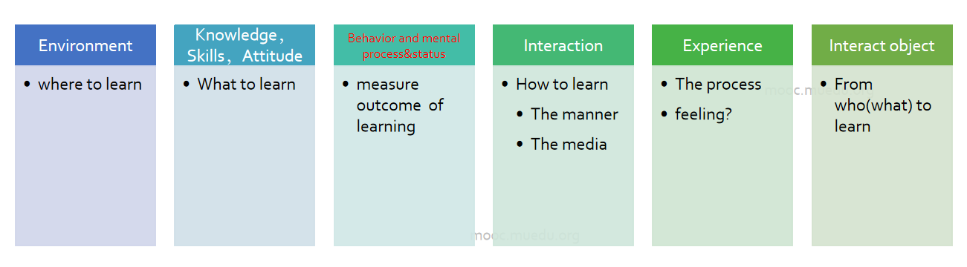

### Figure 2. KIEBIE

这部分需要你们详细阐述自己的设计中的这六个要素。不能泛泛而谈。比如，你的最终环境是什么样的，web应用还是桌面应用，是虚拟现实还是....为什么要这样。

## 5.1 Environment

## 5.2 Knowledge，Skills，Attitude

## 5.3 Behavior and mental process&status

## 5.4 Interaction

## 5.5 Experience

## 5.6 Interact Object

Include sufficient detail to show the important results of the concept generation process, including (as applicable) brainstorming lists, mind-mapping charts, affinity diagrams, sketches/drawings of concepts (hand sketches or CAD drawings approximately scaled, including users in operating position(s)), etc.

Include some discussion of features that may serve as "delighters" - unique or unexpected features that could distinguish your product.

## Initial Screening for Feasibility and Effectiveness

Describe the method of concept screening (for possible methods, see [http://www.ent.ohiou.edu/~me470/SnrDesign05_06/me470/Conceptselection_MITmodified.pdf)](http://www.ent.ohiou.edu/%7Eme470/SnrDesign05_06/me470/Conceptselection_MITmodified.pdf)) Include appropriate evaluation of the alternatives to judge feasibility relative to the specifications and criteria. Document the feasibility of numerous (>3) feasible alternatives.

# Learning Theory

## What learning theory do you mainly applying

## Whay do you applying this(these) theory

# Technology applying

在本节，你需要阐述设计中考虑使用的最有价值的技术，该技术为何能在你们的平台中发挥效果。

# Learning Analytic

详细阐述如何在你的设计中应用xapi或等价技术获取用户的数据。

那些界面操作获取那些数据。

## What data do you need?

Your first step in designing statements is to figure out what data about the learning experiences you’re designing you’ll need to capture. This needs to be a detailed list of every piece of data you’ll capture about each learning experience. At this stage, don’t worry so much about how you will get the data or even if getting that data is possible; work out what you’ll need in an ideal world.

The following questions will help you to compile that list:

* What different experiences is your solution made of? Consider this at both a high level and a more granular level.
* What data do you need in order to generate reports required by your stakeholders?
* What data do you need in order to answer questions posed by your [learning analytics](https://xapi.com/learning-design-transformed" \l "learning-analytics)?
* How will the learning experience adapt to the learner? What data do you need from other experiences to support this?
* What data do you need to inform the design of future similar experiences?
* What data do you currently collect and why? Do you still need that data?

## How will you capture that data?

Once you’ve determined what data you want to collect, you need to plan out how you will get that data and figure out what’s feasible within your budget. There are a few different approaches to collect data about experiences and the most appropriate approach will vary for different experiences and different contexts:

* Embed xAPI tracking directly into the experience. This is normally the best approach for e-learning content and can be the best approach for tracking job performance via business systems you control.
* Use a connector application to pull data out of an existing system and translate it into a xAPI format. This is often the approach used for tracking software that you are not able to customize.
* Track an event related to the experience rather than the experience itself. For example you might track that somebody followed a link to a website rather than tracking the website itself.
* Enable the learner to self-report the experience, perhaps using a [bookmarklet](https://xapi.com/bookmarklet) for websites or a mobile app for real world experiences. This is often the best approach for self-directed learning.
* Enable somebody else to report on the learner’s experiences and achievements, such as a manager, coach, colleague or customer. This is most appropriate when assessing real-world performance.

However you are tracking, there will be cost implications, and that cost will influence how you track. In some cases you may decide to go without a piece of data due to costs associated with obtaining it. Work with your technical team to figure out what is and isn’t feasible.

## How will you structure the data?

Having determined what data to capture and how to capture it, you can now think about how that data will be structured as xAPI statements. Your developer will [dive into the details of statements](https://xapi.com/statements), but as a learning designer, you need to understand the high level basics. The table below outlines the structure of a xAPI statements and the considerations you need to think about as a designer.

|  |  |  |
| --- | --- | --- |
| **Element** | **Explanation** | **Considerations** |
| Actor | An identity of the person who did the thing. People often have multiple identities e.g. personal and work email, Twitter etc. Only one is assigned to the experience. | Who is the person that the experience is about? See [Who Did It?](https://xapi.com/blog/who-did-it/) Is the actor a single person or a group? Which identity is most appropriate to use in this context? Are there any privacy issues? Will you need to associate multiple identifiers used to track different experiences? |
| Verb | The action being done by the actor. | Work with your developer to choose the most appropriate verb identifier. Will statements be displayed in multiple languages? If so, will verb translations be stored within statements or hosted elsewhere? |
| Object | The thing the actor is acting on. This is normally an activity, but can also be a person, group or even another statement. | What information do you need to capture about the activity itself?  How will you create the activity id and ensure it’s unique? See [Get the activity ID right](https://xapi.com/content" \l "get-activity-id-right) |
| Result | The outcome of the experience e.g. success, completion, score etc. | What does ‘result’ look like in the context of the experience you are tracking? Does it fit with the concept of pass/fail and complete/incomplete or do you need to track different data points using extensions? |
| Context | The context of the experience, e.g. the larger learning activity this formed a part of, any other related activities, the instructor or team, the platform and language used in the experience. | What information about the context of the experience needs to be captured? How does the concept of ‘attempts’ work in your learning solution? This may be represented within the context. |
| Authority | The person or group that asserts that the thing happened. The authority is set by the Learning Record Store based on the security credentials used. | Authority allows you to mark the source of the data so you can make use of data from more and less reliable sources. Consider how the authority of data will be represented in reporting and analytics. |
| Timestamp | When the experience happened; not necessarily when the data was stored. | Will you need to store tracking data offline to be sent later? |
| Attachments | Files attached can be attached to the statement e.g. evidence of a learning activity. | Attachments can be useful, but consider data storage and performance implications. |

The table above gives you a very high level view of xAPI statements. To go further, read the [Statements 101](https://xapi.com/statements-101) or [Statements deep dive](https://xapi.com/statements) resources for developers.

# UX evaluation

由于没有真正实现出来，因此无法对学习效果（KIEBIE中的behaivor，mental部分）开展真正的评估。但是你们设计的原型系统是可以点击体验的 ，因此在这个报告中，需要依照上次发放的评估技术来对自己的项目进行评估。

***你们自己收集数据，分析获得结果，此结果是一项最终打分依据。此处，切结遵守学术道德规范，不得篡改数据。***

# Final Design

Discuss details of the design refinement process and the final detailed design. Start with a system level description that flows down to the subsystem and component level.

The project must include both thermal and mechanical design aspects, so make sure that both aspects of your project are described.

It is suggested that you use FMEA to organize the discussion of how the critical design areas were identified and what methods were used to develop a safe and effective final design. Describe how you did the FMEA and what the results were, and make reference to actual FMEA worksheets included in the appendix.

Show highlights of the key analysis that was done to justify design decisions, and include the results and conclusions from the analysis in the body of the report (place the details of any significant analysis in the appendix).

For all significant design decisions (items identified by FMEA to be important decisions), provide clear and complete justification that includes all aspects of the decision (to demonstrate that a good design process was followed to achieve a good decision).

|  |  |  |
| --- | --- | --- |
| **Acceptable / Supported decisions include most of the following considerations** | | |
| **Considerations** | **In-Process (Design Refinement) Level** | **Completed Decision Level** |
| **Impacts / Effects** (First, do no harm. Immediate and long term, intended and unintended, local and global impacts of products and production on the  environment and society) | Considered for the overall project, and is impacting production and part-level decisions. | All aspects considered and hard choices and tradeoffs are made as required to limit impacts. |
| **Professional and ethical standards** (Decision and Justification show good judgment  and integrity) | Demonstrates a commitment to professional standards. | Demonstrates a commitment to professional standards. |
| **Function** (Research, precedent  and vendor info show it should meet the design specifications) | Complete and up-to-date | Complete and up-to-date |
| **FMEA** (A failure modes and effects analysis or similar technique is properly used to evaluate the overall system failure modes and hazards and to  prioritize risks and focus the design effort. | All Hazards identified and most significant items evaluated. | All significant hazards evaluated and RPNs decreased to acceptable values. |

|  |  |  |
| --- | --- | --- |
| **Design Analysis** (Sufficient and Correct Analysis for part sizing and material selection to avoid failure; Simulations demonstrate performance of major subsystems in critical operating modes.) | All critical load cases and failure locations identified and analysis completed and validated for most critical locations.  Simulations begun with estimated parameters. | Analysis completed and validated for all critical locations. Simulation completed with experimentally validated parameters. |
| **Safety** (All aspects of project and product safety considered continuously throughout the  design process. Design for Safety terminology & approach used.) | Design for safety on a system level is complete. Examples of avoidance  and protection are presented. | A comprehensive approach is documented that shows reduction of all hazards  (product and production) to low risk. |
| **Economics / Value** (Cost/benefit analysis is used to evaluate value, not just immediate cost. A vendor selection process is followed and  documented.) | Most significant items have been analyzed for value and a process is used for vendor selection. | All significant items have been analyzed for value. Good vendor selection process. |
| **Customer** (360 degree Customer Input solicited, evaluated and appropriately used.) | Significant input has been incorporated from various external and internal customers | Usability, marketability and other customer input incorporated from all significant external and  internal customers |
| **DFMA** (All aspects of Manufacturing and Assembly Considered, including manufacturability of design features, use of manufacturing features, machinability of  materials,…) | Manufacturability and assembly of most significant items has been analyzed and improved to appropriate levels. | Manufacturability and assembly of all significant items has been analyzed and improved to appropriate levels. |
| **Testing** (Mock-ups and experiments used for information and validation) | Most mock-ups complete and used appropriately for product development. Other tests are planned. | Mock-ups and tests were used appropriately for numerous aspects of product development. |
| **Other (Creativity and initiative** are evident in the decision process**;** Good **planning and organizing** are demonstrated, including use of **decision making tools** [Pareto analysis, decision matrices and other prioritizing and  organizing tools]; Impacts on design criteria are considered) | Some other considerations are evident. | Most other considerations are evident. |

## How does it work?

In the best way you can, please explain how your design works. Focus on system-level operational details (how the user would operate the system), but include some technical information that describes how the product actually works. Include instructions for maintenance and service, and any assembly steps that must be completed by the customer. This section should be understandable to the target customer, and should be able to serve as product literature (operating manual).

## How is it manufactured and assembled, and what does it cost?

## Design Drawings, Parts List and Bill of Materials

Include in this section, or in an Appendix or design project file referenced from this section, the assembly-level and part-level drawings that summarize and communicate your design. Please provide a set of drawings with sufficient detail to control manufacture and assembly of the final design (i.e. the drawing set could be sent to a manufacturing shop for the final design to be produced). For this project, assembly and subassembly drawings and parts lists should be complete, but it is acceptable to focus on the most significant part-level drawings (but at least one per team member) to do a good job fully dimensioning and tolerancing them. The assembly drawings should show all parts (purchased and manufactured) with part numbers, and the parts list should identify all parts. The assembly drawing should also include all assembly-level dimensions.

Note that detailed drawings are not required for components/subassemblies that are purchased and not modified prior to assembly. These are specified in the parts list and shown with key dimensions to scale in the subassembly/assembly drawings. Supply the best possible purchase information (vendor/part #/part description) for purchased items.

* + Modification drawings are required for purchased parts that require some manufacturing prior to assembly.
  + Do not draw details of standard hardware like nuts, bolts, washers, castors, computers, etc.; just specify them in the Bill of Materials.

The bill of materials lists:

1) Materials and their specifications (sizes and quantity) necessary to manufacture parts and 2) Off-the-shelf hardware. It may include weights and costs.

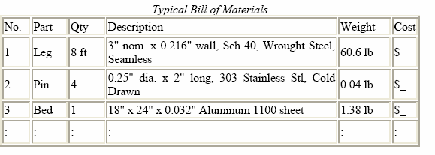

Note: A design project file compiles the drawings and vendor info and all related information, organized by subsystem and part number/part name. It is not a "formal" document like a report, but more like an expanded design notebook organized according to the parts in the assembly.

Using a binder with identification tabs is recommended.

## 7.4 Design validation through test results and operating experience

Explain the tests that were used to validate the performance, usability, safety, and other features of your design, including for each test: 1) the need for information (what you needed to know), 2) the design of the test (to control certain factors) and the test apparatus (if required), 3) the metrics (the targets for what needs to be measured or observed), 4) the measurement system, 5) the results, and

6) lessons learned and design changes.

Also, discuss the continuing influence of the customer in the design process.

# Conclusions

Did your project meet the objective (to design a good solution to the business opportunity and respond to the original needs statement)? Part of the conclusion section should include a specifications table, showing all specification requirements vs. actual values for the final design. Using the performance relative to specs along with performance relative to the design criteria, address the true value of your design. Make sure to highlight the "delighters" and the truly unique features you have added to your design.

Also remember to include info on:

* Environmental: The design (and any fuels or power sources) should be evaluated for total environmental impact, including concerns related to energy use, emissions, and total life cycle issues (environmental impacts of production methods [hazardous materials?] and product retirement [longevity and recyclability])
* Political: Identify existing government policies that are supportive of the project.

### [Note that the following part of the conclusion section will be done individually as part of the executive summary. There is no need to include it in the team report.]

This is a technical report, not a sales brochure, so make sure to be brutally honest in your appraisal

of the overall design and its state of readiness for production.

* Clearly state whether or not you believe the project should be continued or cancelled (based on your improved understanding of the market, the production costs, and the overall impact that producing this design is likely to have relative to addressing the original needs statement (the current energy situation). Justify your recommendation.
* If it should be continued but is not ready for production, clearly state (in specific actions, not generalities) what needs to be done to reach the "production-ready" state, and attempt to place a schedule and budget on the remaining work.

# References (Times New Roman, 16, Bold)

*Note: That for the author-date system, references are listed in alphabetical order.*

Muriru, P.K. and Daewoo, R., “Prediction of the Heat Transfer Characteristics of a Multi-Flame Injector'”, Combustion and Flame, vol. 100, no. 2, pp. 123-135, 2002.

*th*

Peters, L., Johnson, M., and Davidson, K., “A Novel Approach to Four-Bar Synthesis'”, *10 Design Automation Conference*, pp. 234-250, Pittsburgh, PA, 2001.

*ASME*

Swanson Inc., “Online Users Manual for ANSYS 5.0'', *<http://www.ansys.com/>manual*, viewed on March 1999.

Wen-Cheng, C., “Electric Bicycle'”, US Patent no. 5,368,122, November 29, 1994.

Zacharia, M. and Daudi, P.K., The Effect of Multi-materials on Conventional Finite Element Formulations, New York: Wiley and Sons, 2001.

Deadline:23:59, 2020-01-03

Submit: submit to your team github repository.